# Package Installation Guide

## Step by step guide to install and update packages

This section will detail the system requirements and UiPath packages to be available in the system to ensure that it executes the codes correctly. Follow the steps to install the package in UiPath studio:

**Step 1.** Click on Manage Packages.

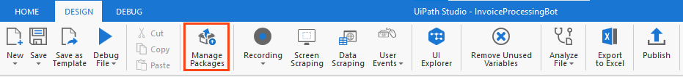

Figure 1 Manage Packages Ribbon Bar

**Step 2.** Search the package according to the project requirement.

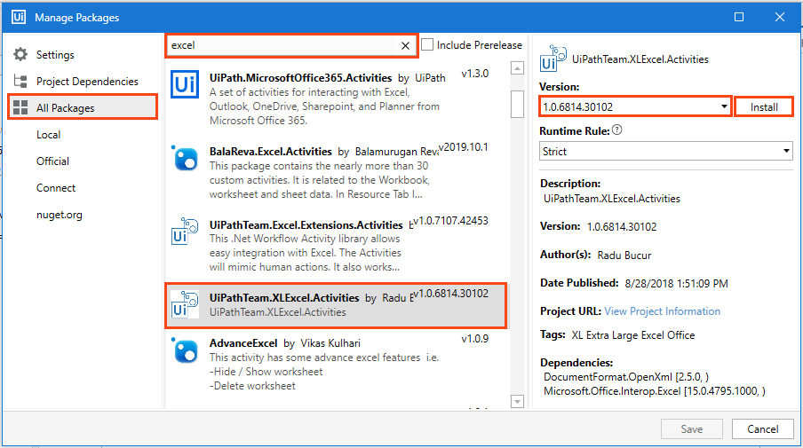

Figure 2 Package Installation

**Step 3:** Select the package and the version to be installed.

**Step 4:** Save the packages by clicking on the “Save” button.

## Viewing list of installed Packages

To view the packages used in code, right-click on the “Dependencies” option of “Project” panel and select “Manage” option (refer Figure 3).

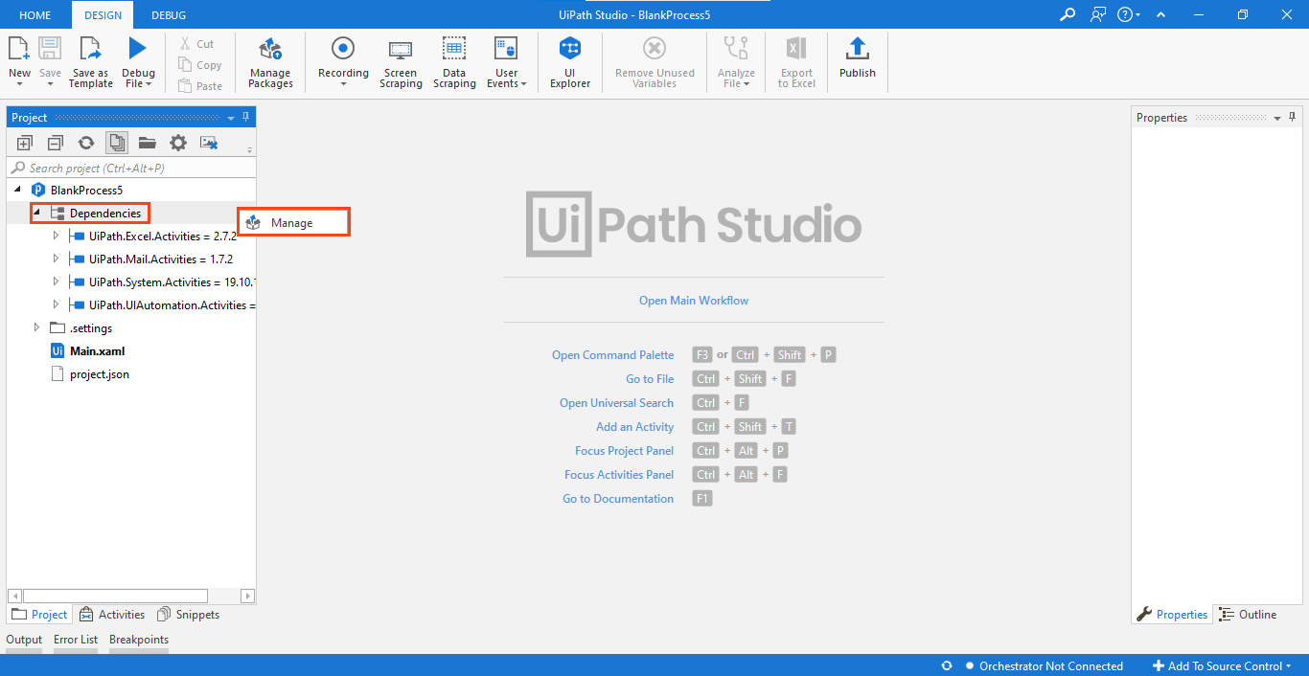

Figure 3 Installed Packages List

Note: For the codes which involve browser usage, the browser should have its extension installed. You can install an extension from the 'Tools' section of UiPath Studio.

# Basic Projects

## Sales Order Processing Robot

The code comprises of six UiPath packages (refer Table 1), and they must be installed in the UiPath studio for the Robot to execute the task successfully.

|  |
| --- |
| * UiPath.Excel.Activities * Uipath.Mail.Activities * UiPath.PDF.Activities. * UiPath.System.Activities * UiPath.UIAtuomation.Activities * Uipath.web.Activities |

Table 1 List of Packages used in Sales Order Processing Robot

The above-listed packages used can be viewed on the left side of the "Project” panel tab

(refer Figure 4).

|  |
| --- |
|  |
| Figure 4 List of packages used in Sales Order Processing Robot |

Right-click on “Dependencies” and select “Manage” to view all project dependencies (refer Figure 5).

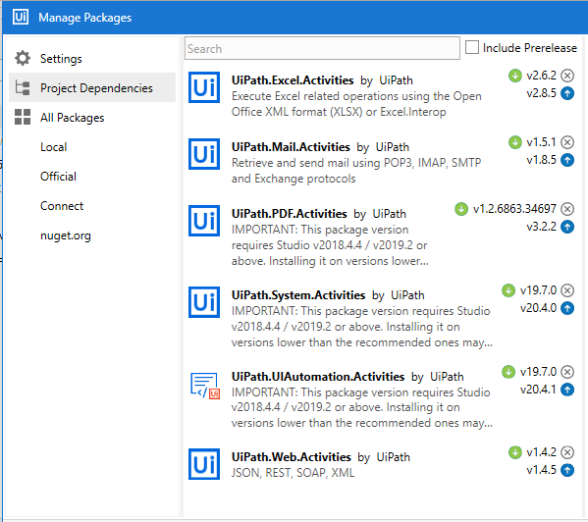

Figure 5 Project Dependencies in ‘Sales Order Processing’ Robot

**Note: If a package appears in 'Red', it indicates a problem. To resolve it, right-click on the package name and click resolve/update.**

**Prerequisites:**

Outlook application should be configured on your device.

‘**Order Entry.exe**’ application and ‘**Sample Invoice**’ should be available in the ‘**Prerequisite**’ folder of Project folder.

The subject of the email should be ‘**Sales Invoice**’.

The ‘**Sample Invoice**’ file should be downloaded and emailed with the subject ‘**Sales Invoice**’ to the email id configured in outlook.

The email with the subject line as ‘**Sales Invoice**’ should be the last unread email before running the code.

The '**data**' folder in the '**Project**' folder should be empty before running the Robot.

## Process Flow

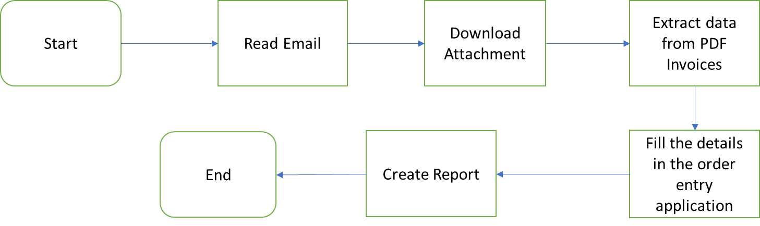

## Applications to be used

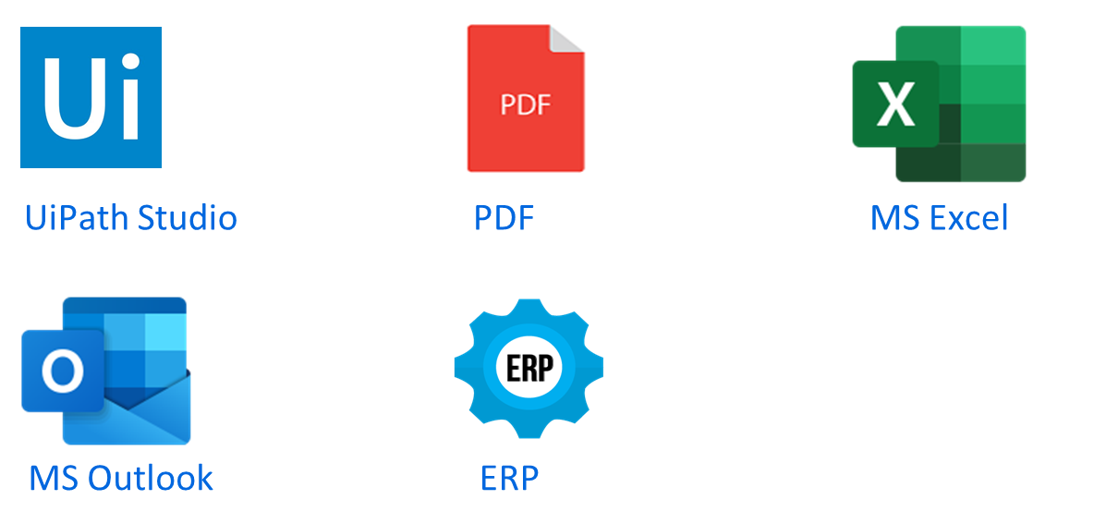

Based on the scope, applications to be used for Sales Order Entry Robot are:

1. **UiPath Studio:** UiPath will enable you to design the automation process in a visual manner.
2. **Microsoft Outlook:** UiPath will use Outlook to extract sales invoice attachment from unread emails.
3. **PDF:** The invoice will be in Portable Document Format (PDF). The Robot will extract the specified information from the PDF file.
4. **ERP:** The Robot will enter the information in the ERP system.
5. **Microsoft Excel:** An excel file will be used to store the data updated in the ERP.

## Process steps

**Project Overview:** This project aims to build a Robot for automating the sales order entry process in an organization. The Robot will read emails and download the sales invoice received in the form of an email attachment. It should read the attachment and extract the below mentioned information which will then be entered in the ‘Order Entry’ application:

* Invoice No.
* Invoice Date
* Item No
* Description
* Quantity
* Price
* Sub Total
* GST
* Total

The Robot will also extract company and customer details from the attachment, which will also be entered in the ‘Order Entry’ application.

*Company Details:*

* Name
* Address
* City
* State
* Pin Code
* Contact No.
* Tin

*Customer Details:*

* Customer Name
* Customer Address
* City
* State
* Pin Code
* Contact No.
* Tin

Once the information is entered in the ‘Order Entry’ application, the robot will fill an excel report with the below mentioned details:

* Invoice Number
* No of Items
* Time stamp

## Steps to make a Sales Order Entry Robot:

**Step 1:** The Robot will read the last unread emailfromthe Outlook.

**Step 2:** After reading the email it will download the attachment, i.e. **‘Sample Invoice.pdf’**.

**Step 3:** It saves the attachment file in the **Data** folder, which has already been created and is available in the project folder.

**Step 4:** And then it will extract the relevant fields from document.

**Step 5:** Once the relevant information is extracted, it will insert those details in **“Order Entry.exe**” application.

**Step 6:** It will then create an excel file with the name “**report.xlsx”** in the project folder and update the fields with Invoice Number, Items, Timestamp, and Status.

**Step 7:** The robot will successfully end the process after the report is created.

## Appendix

**1. What is a sales order?**

A sales order is a document that is generated by the seller after he receives a purchase order from the buyer. It contains details about the product or service along with the price, quantity, value, status of the product, user names, billing address and terms & condition.

**2. What is ERP?**

ERP or Enterprise Resource Planning is the management of business processes that happens in real time. ERP handles various activities such as data interpretation, accounting, payroll, raw material management, production and many more.